**Configure SASL_PLAINTEXT to the Kafka bootstrap server**

1.Refer the folder kafka-source-authentication🡪 plaintext-auth-setup-

2. Follow the steps mentioned in the **Kafka SASL PLAINTEXT Authentication.docx**

**Configure OAuth to the Kafka bootstrap server**

1. Refer the folder kafka-source-authentication🡪oauth-setup.
2. Copy the below files int to the config folder of your Kafka.
3. command_config_sasl_oauth
4. kafka_server_sasl_oauth_jaas
5. server.properties
6. server_sasl_oauth.properties
7. Please make the respective changes to the below fields which is mentioned in the files from steps 2(a) to 2(d).

**clientId** = which is crated in the Okta server

**clientSecret** = which is available from the Okta server. Please refer the below screen shot for more details.

**LoginStringClaim_sub** = same as clientId

**Scope** = we should create a scope in the Okta server

We create an **Applications** first, as seen below to get the clientId and clientSecret.

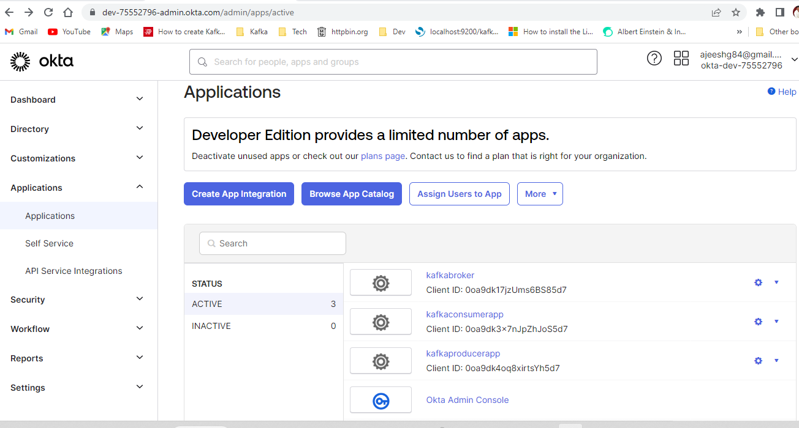

Once you click on the application which you created, and it will be redirected to the below page detailing the clientId and secret.

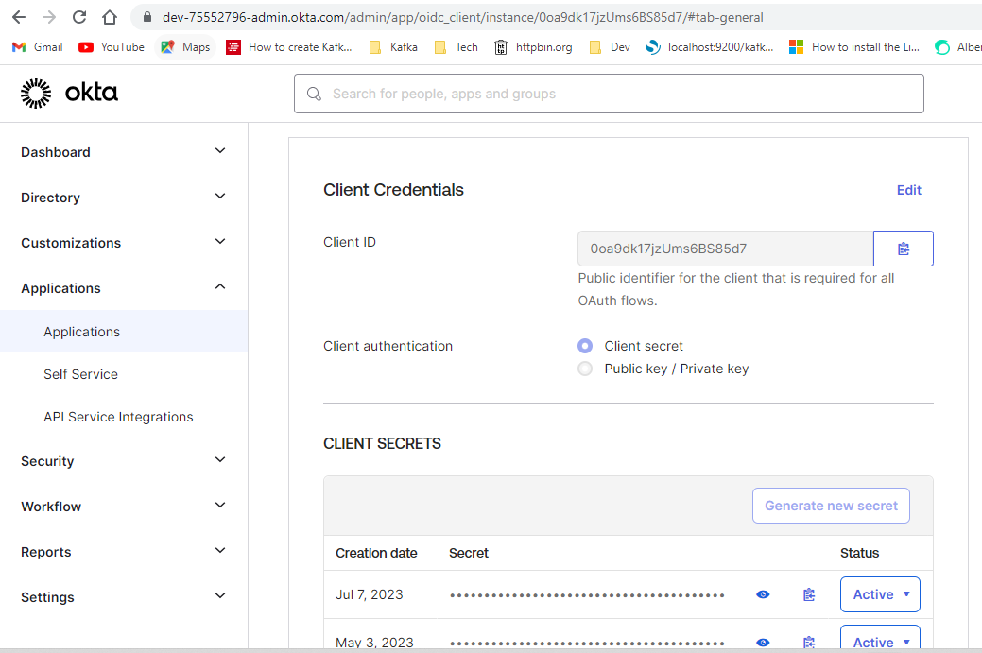

To create a TOKEN, please refer Okta dashboard-🡪Security🡪API

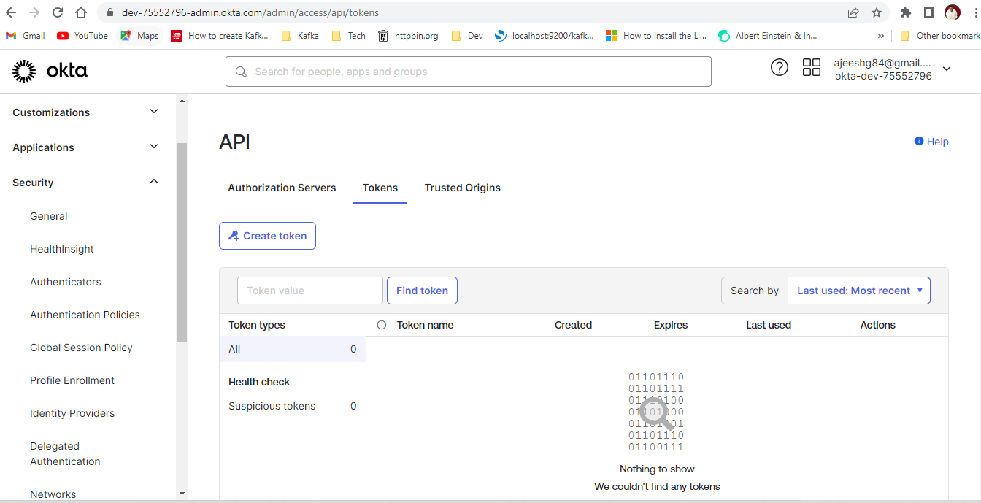

1. Please refer the file **commands (inside** Kafka-source-authentication🡪oauth-setup) for all the available commands to execute.
2. Now the Kafka broker is configured with the oauth
3. Please delete all the Kafka and Zookeeper related logs before executing the step 4 to avoid exception or runtime errors in sometimes.